ECE 424

Lab 3

Graham Guthrie

September 16, 2017

I. Introduction

In the third lab, we were tasked with creating an encoder and decoder. The lab proved to be time consuming and extensive. For the pre-lab, several K-maps were constructed from truth tables. Logic equations were derived from the K-maps which aided in the design of each circuit. The lab was difficult but manageable, and both circuits were successfully deployed.

II. Procedure

The lab was again broken into two parts. For the first part, we were instructed to build an encoder. The lab documentation described the logic behind the encoder. From there, we wrote the truth table as part of the pre lab requirements. After the truth table was derived, K-maps were used in order to produce the logic expressions for each of the outputs. The schematic was then constructed, and the same process as the other two labs was used to deploy the encoder. Pins were assigned, the designed was then compiled, a functional simulation was run, and then the circuit was deployed onto the board. To answer the pre lab question about the number of total inputs that could be used without increasing the number of outputs, we analyzed the truth table. Since there are three outputs, a total of seven inputs could be used because the outputs represent 3 bits.

For the second part of the lab, we were instructed to build a seven segment decoder. A partial truth table was given in the lab documentation. We completed the truth table and then built K-maps for each of the output segments. This part of the lab was extensive and error prone. After several checks, the schematic was built. Building the circuit was a slow process. After completion, pins were assigned and a functional simulation was run. I had two errors with my outputs. The errors were easily diagnosed and the schematic was adjusted. Another functional simulation was run and was successful. The circuit was then deployed onto the board. In response to the pre lab question, in order to control two numbers, a second set of inputs could be added along with some form of a multiplexer on the outputs. All figures, tables, and equations can be found below.

|  |  |  |  |  |  |  |
| --- | --- | --- | --- | --- | --- | --- |
| I3 | I2 | I1 | I0 | C2 | C1 | C0 |
| 0 | 0 | 0 | 0 | 0 | 0 | 0 |
| 0 | 0 | 0 | 1 | 0 | 0 | 1 |
| 0 | 0 | 1 | X | 0 | 1 | 0 |
| 0 | 1 | X | X | 0 | 1 | 1 |
| 1 | X | X | X | 1 | 0 | 0 |

Table 1- Encoder Truth Table

|  |  |  |  |  |  |
| --- | --- | --- | --- | --- | --- |
|  | I2I3 |  | | | |
| I0I1 |  | 00 | 01 | 11 | 10 |
|  | 00 | 0 | 0 | 0 | 1 |
| 01 | 0 | 0 | 0 | 1 |
| 11 | 0 | 0 | 0 | 1 |
| 10 | 1 | 0 | 0 | 1 |

Table 2- C0 K-map

C0 = I2 /I3 + I0 /I1 /I3

|  |  |  |  |  |  |
| --- | --- | --- | --- | --- | --- |
|  | I2I3 |  | | | |
| I0I1 |  | 00 | 01 | 11 | 10 |
|  | 00 | 0 | 0 | 0 | 1 |
| 01 | 1 | 0 | 0 | 1 |
| 11 | 1 | 0 | 0 | 1 |
| 10 | 0 | 0 | 0 | 1 |

Table 3- C1 K-map

C1 = I2 /I3 + I1 /I3

|  |  |  |  |  |  |
| --- | --- | --- | --- | --- | --- |
|  | I2I3 |  | | | |
| I0I1 |  | 00 | 01 | 11 | 10 |
|  | 00 | 0 | 1 | 1 | 0 |
| 01 | 0 | 1 | 1 | 0 |
| 11 | 0 | 1 | 1 | 0 |
| 10 | 0 | 1 | 1 | 0 |

Table 4- C2 K-map

C2 = I3

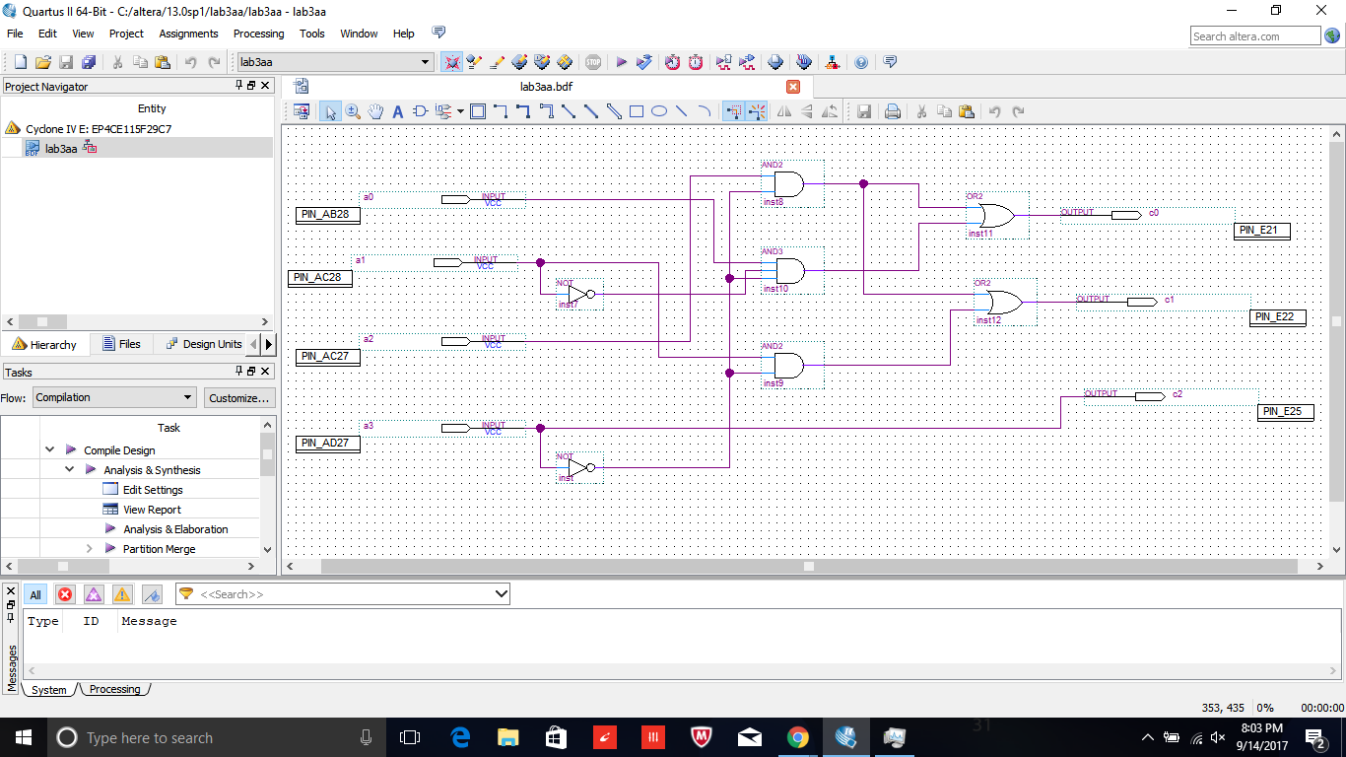

Figure 1- Schematic of Encoder

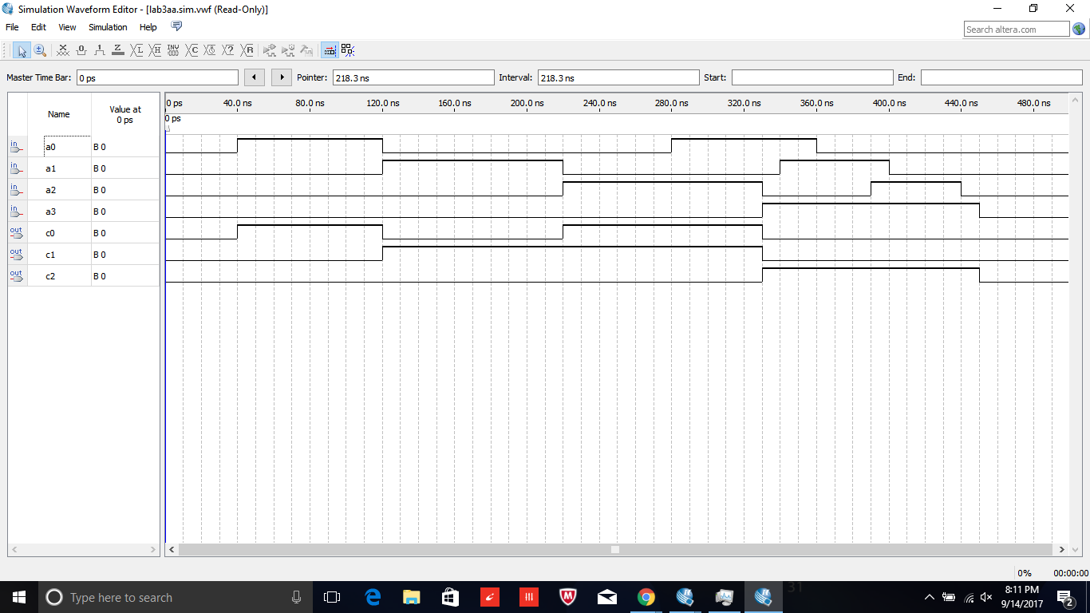

Figure 2- Waveform of Encoder

|  |  |  |  |  |  |  |  |  |  |  |  |
| --- | --- | --- | --- | --- | --- | --- | --- | --- | --- | --- | --- |
| Binary Inputs | | | | Decoder Outputs | | | | | | | O |
| A | B | C | D | a | b | c | d | e | f | g |  |
| 0 | 0 | 0 | 0 | 1 | 1 | 1 | 1 | 1 | 1 | 0 | 0 |
| 0 | 0 | 0 | 1 | 0 | 1 | 1 | 0 | 0 | 0 | 0 | 1 |
| 0 | 0 | 1 | 0 | 1 | 1 | 0 | 1 | 1 | 0 | 1 | 2 |
| 0 | 0 | 1 | 1 | 1 | 1 | 1 | 1 | 0 | 0 | 1 | 3 |
| 0 | 1 | 0 | 0 | 0 | 1 | 1 | 0 | 0 | 1 | 1 | 4 |
| 0 | 1 | 0 | 1 | 1 | 0 | 1 | 1 | 0 | 1 | 1 | 5 |
| 0 | 1 | 1 | 0 | 1 | 0 | 1 | 1 | 1 | 1 | 1 | 6 |
| 0 | 1 | 1 | 1 | 1 | 1 | 1 | 0 | 0 | 0 | 0 | 7 |
| 1 | 0 | 0 | 0 | 1 | 1 | 1 | 1 | 1 | 1 | 1 | 8 |
| 1 | 0 | 0 | 1 | 1 | 1 | 1 | 1 | 0 | 1 | 1 | 9 |
| 1 | 0 | 1 | 0 | 1 | 1 | 1 | 0 | 1 | 1 | 1 | A |
| 1 | 0 | 1 | 1 | 0 | 0 | 1 | 1 | 1 | 1 | 1 | b |
| 1 | 1 | 0 | 0 | 1 | 0 | 0 | 1 | 1 | 1 | 0 | C |
| 1 | 1 | 0 | 1 | 0 | 1 | 1 | 1 | 1 | 0 | 1 | d |
| 1 | 1 | 1 | 0 | 1 | 0 | 0 | 1 | 1 | 1 | 1 | E |
| 1 | 1 | 1 | 1 | 1 | 0 | 0 | 0 | 1 | 1 | 1 | F |

Table 5- Seven Segment Decoder Truth Table

|  |  |  |  |  |  |
| --- | --- | --- | --- | --- | --- |
|  | CD |  | | | |
| AB |  | 00 | 01 | 11 | 10 |
|  | 00 | 1 | 0 | 1 | 1 |
| 01 | 0 | 1 | 1 | 1 |
| 11 | 1 | 0 | 1 | 1 |
| 10 | 1 | 1 | 0 | 1 |

Table 6- a Segment K-map

a = C/D + /B/D + A/D + A/B/C + /ABD + BC + /AC

|  |  |  |  |  |  |
| --- | --- | --- | --- | --- | --- |
|  | CD |  | | | |
| AB |  | 00 | 01 | 11 | 10 |
|  | 00 | 1 | 1 | 1 | 1 |
| 01 | 1 | 0 | 1 | 0 |
| 11 | 0 | 1 | 0 | 0 |
| 10 | 1 | 1 | 0 | 1 |

Table 7- b Segment K-map

b = /A/B + /B/C + /A/C/D + A/CD + /ACD + /B/D

|  |  |  |  |  |  |
| --- | --- | --- | --- | --- | --- |
|  | CD |  | | | |
| AB |  | 00 | 01 | 11 | 10 |
|  | 00 | 1 | 1 | 1 | 0 |
| 01 | 1 | 1 | 1 | 1 |
| 11 | 0 | 1 | 0 | 0 |
| 10 | 1 | 1 | 1 | 1 |

Table 8- c Segment K-map

c = /A + /B + /CD

|  |  |  |  |  |  |
| --- | --- | --- | --- | --- | --- |
|  | CD |  | | | |
| AB |  | 00 | 01 | 11 | 10 |
|  | 00 | 1 | 0 | 1 | 1 |
| 01 | 0 | 1 | 0 | 1 |
| 11 | 1 | 1 | 0 | 1 |
| 10 | 1 | 1 | 1 | 0 |

Table 9- d Segment K-map

d = A/C + A/BD + BC/D + B/CD + /B/C/D + /A/BC

|  |  |  |  |  |  |
| --- | --- | --- | --- | --- | --- |
|  | CD |  | | | |
| AB |  | 00 | 01 | 11 | 10 |
|  | 00 | 1 | 0 | 0 | 1 |
| 01 | 0 | 0 | 0 | 1 |
| 11 | 1 | 1 | 1 | 1 |
| 10 | 1 | 0 | 1 | 1 |

Table 10- e Segment K-map

e = C/D + AB + /B/D + AC

|  |  |  |  |  |  |
| --- | --- | --- | --- | --- | --- |
|  | CD |  | | | |
| AB |  | 00 | 01 | 11 | 10 |
|  | 00 | 1 | 0 | 0 | 0 |
| 01 | 1 | 1 | 0 | 1 |
| 11 | 1 | 0 | 1 | 1 |
| 10 | 1 | 1 | 1 | 1 |

Table 11- f Segment K-map

f = /C/D + /AB/C + A/B + AC + BC/D

|  |  |  |  |  |  |
| --- | --- | --- | --- | --- | --- |
|  | CD |  | | | |
| AB |  | 00 | 01 | 11 | 10 |
|  | 00 | 0 | 0 | 1 | 1 |
| 01 | 1 | 1 | 0 | 1 |
| 11 | 0 | 1 | 1 | 1 |
| 10 | 1 | 1 | 1 | 1 |

Table 12- g Segment K-map

g = C/D + /BC + AD + A/B + /AB/C

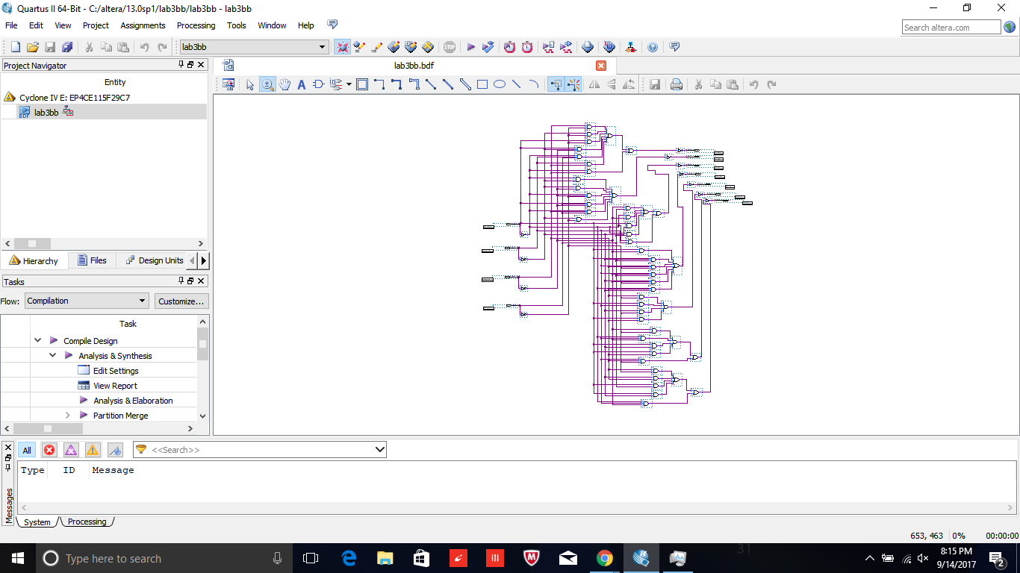

Figure 3- Full Schematic of Decoder

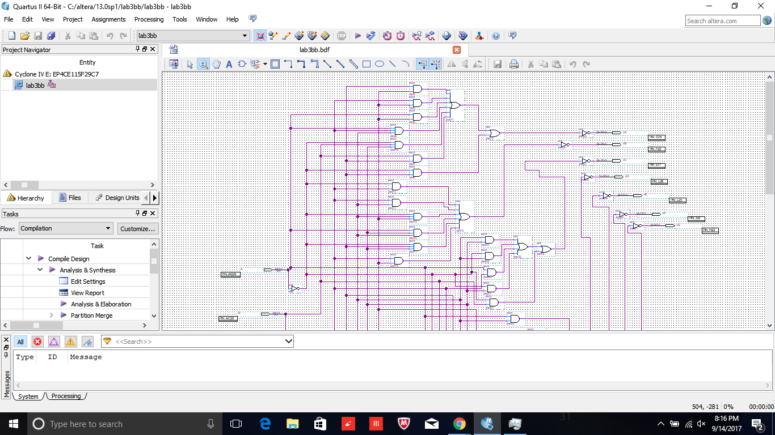

Figure 4- Upper Half of Decoder

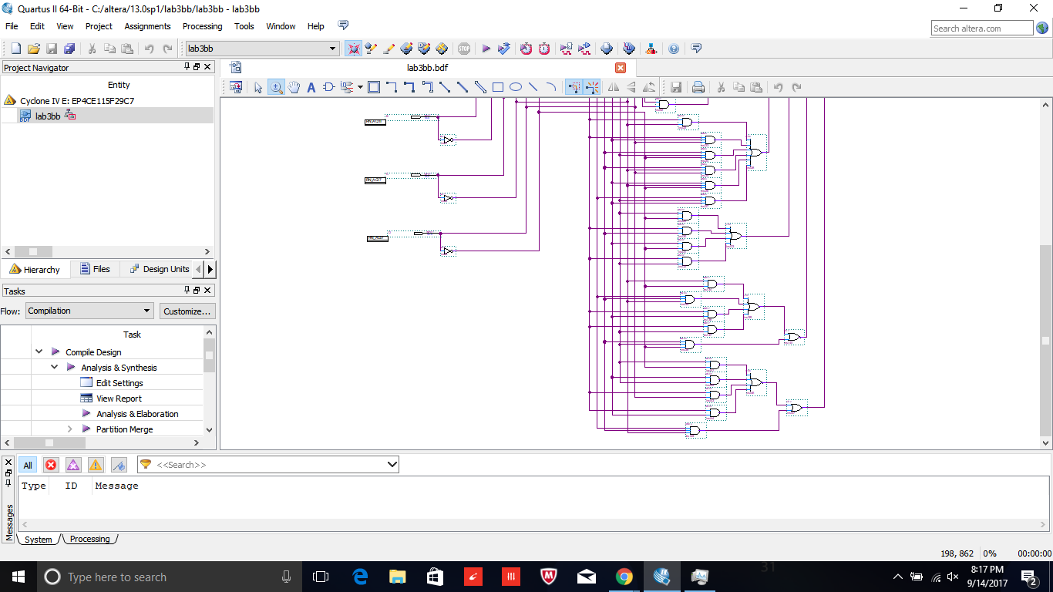

Figure 5- Lower Half of Decoder

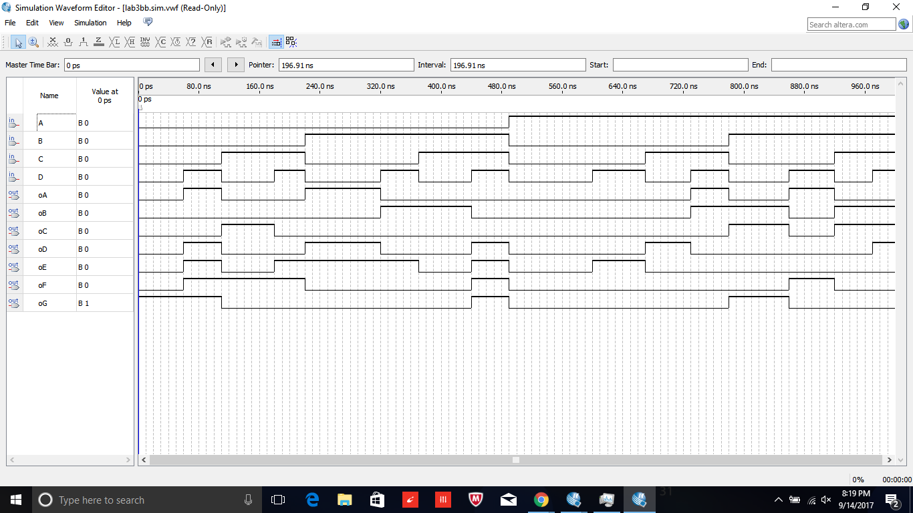

Figure 6- Waveform of Decoder

III. Conclusion

Overall, this lab was extensive and frustrating at times. The first part of the lab was similar to earlier labs. The second part of the lab was the most difficult circuit that we have had to build thus far. It took me a couple attempts because my K-maps were initially inaccurate. After several checks, I figured it out. The functional simulation definitely helped me figure out my errors quickly and efficiently. The lab documentation was fairly straightforward, and made it easy to stay on task. I enjoyed the challenge of the lab.